**Matlab HW4 Report**

**電機二 B09602017 白宗民**

Figures:

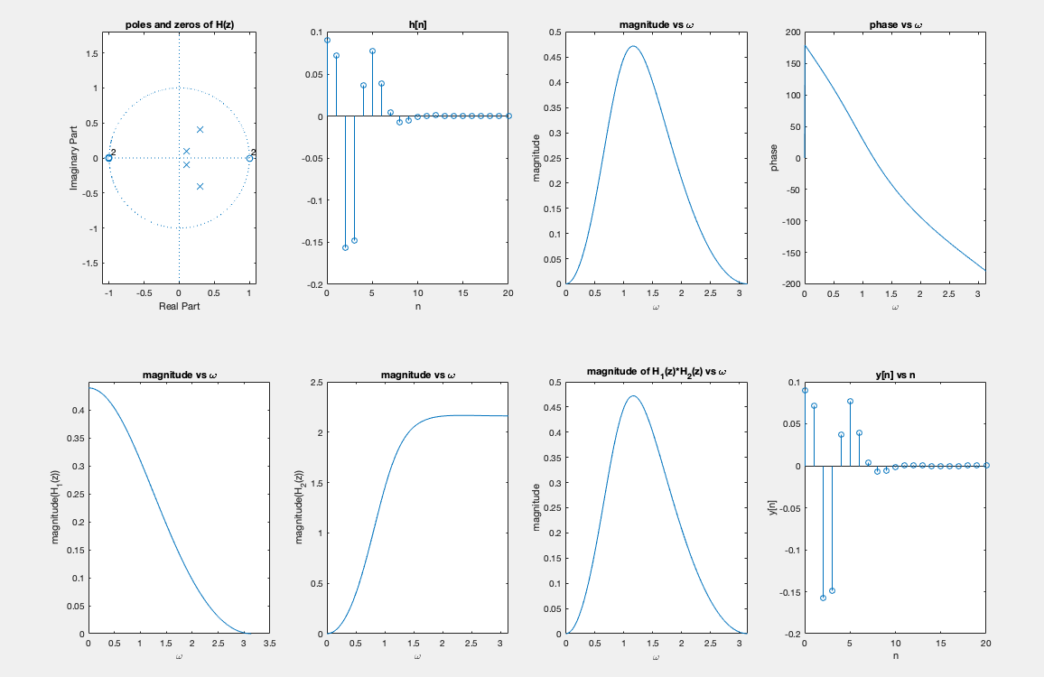

ROC : |z| > 0.5

(d)

H1(z) =

H2(z) =

(e)

They’re both different from that of (c).

(f)

They’re both the same as that of (c).